BETWEEN FRIENDS
Newsletter of the Vancouver Monthly Meeting of the
Religious Society of Friends (Quakers)
http://vancouver.quaker.ca/
July 2015
NOTE FROM THE EDITOR: The opinions expressed in this Newsletter are the opinions of the individual authors and may not reflect the opinions of the Newsletter Committee or of Quakers generally. (This applies to past, present, and future issues of Between Friends.)

Newsletter items are now to be forwarded to Vancouverquakernewsletter@outlook.com

Round The Kitchen Part 2

Now the last time we were heading for the actual 'kitchen'/ food preparation area in this case may be a better description after having gone through things about the washrooms/ and we covered all that and the things that might found in the janitorial closet, but the kitchen is just a little more complicated. I think the best thing to do is just ask; there are dishes and bowls and pots and pans and knives and forks and even spoons that are suppose to be there, but to be on the safe side bring along one of those boy scout knives or come ready for finger food.
The elephant in the room, of course is the stove...its not the latest model...might have been popular in the early eighties and some of the top burner igniters don't always work...suggest use long matches (you don't usually see these things around any more, so have fun with them.
The oven itself has up/down control for temperature..so just set it to desired amount and the stove doesn't have a timer (at least one that I haven't discovered, so remember to take out the roast and turn the oven off (that maybe labelled 'cancel')...again, to be on the safe side...don't hesitate to ask or just run out of the kitchen screaming!
I don't know if we have time to cover the refrigerator and 'pantry' cupboard?
Simple enough, eh! If food dishes are not marked as to last date and content, or if salad dressing bottles have a best before date and its something like 'Vermont Ranch 'June/94 you may do the responsible thing and I would suggest that if you were going to leave a water bottle in the fridge identify it with some special mark...this is the nearest we are to a secret society and love and forgiveness particularly in this round about is treasured.

Al Mytkowicz
Bldgs&Grnds

Helping the Unitarians to Help Eritrean Refugees

“The Eritrean refugee promised his cousin he would apply to sponsor her as soon as he got settled in Winnipeg in 2012. He didn't know the Canadian government was about to slam the door shut on any new refugee applications. Neither did she. Senait Gabir, 28, drowned this winter in the Mediterranean, along with hundreds of other asylum-seekers trying to get someplace safe. The refugee fled Eritrea -- "the North Korea of Africa" -- and took a chance with human smugglers on a perilous journey, said her cousin in Winnipeg, Teklzghi (Tek) Yohannes. "You have to live there to know it," said Yohannes, 38. "That's why people take a risk to die."
(May 15, 2015, Winnipeg Free Press)

So begins a recent post from the Refugee Committee of the Unitarian Church of Vancouver. The article continues:

" In 2012, the federal government capped the number of privately sponsored refugees to deal with a backlog of applications. There's no sign of the cap being lifted any time soon, said Winnipeg refugee advocate Jim Mair. ". “A lot of people are going to be denied an opportunity to come here,' said Mair, vice-president of the Canadian Council for Refugees. . .. 'A lot of families are not going to be reunited, and Canada will keep slipping in the world's view of how welcoming we used to be,' said Mair. "Meanwhile, refugees in Africa from countries such as Eritrea, Somalia and Syria continue risking their lives trying to get to Europe, and some will end up dead like Gabir. Last month, the UN reported an estimated 31,500 people have crossed the Mediterranean to Italy and Greece so far this year, and an estimated 1,600 people have died trying.. . ."

Unitarians appeal for our support
The Unitarian Church of Vancouver's Refugee Committee has taken on numerous sponsorships over the years, starting in the 1970s with Vietnamese refugees. Since then they have sponsored or helped sponsor people from Burundi and Togo (I believe VaMM was somewhat involved in this case, through Nancy Miller's involvement - and raised some funds to help the political refugee, singer-songwriter Lazare Halk and his young family), a young Eritrean adolescent in a joint sponsorship, a Karen family from Burma in a blended sponsorship, a family from Afghanistan, and several related Palestinian refugee families and individuals - stateless persons stranded in the Al-Hol refugee camp in Syria (VaMM helped to assist one of the families). They currently have applications pending for several more, and are expecting a family of four Tibetans to arrive in early August.
The UCV Refugee Committee have also undertaken the "blended" (i.e., shared 50-50 with the government) sponsorship of two young Eritrean women, 24 and 26 years old, who are currently in a Cairo refugee camp. "Let's hope we can be the difference for those two young women!" writes Julia Myers of the UCV committee.

This is where we come in
These two young women have been approved by the Canadian Visa office in Cairo for a blended sponsorship, and the UCV Refugee Committee is wondering whether Vancouver Friends might feel led to join with them in easing their transition to Canada.

What does this mean?
Vancouver Friends are being invited to assist at whatever level they are able to commit to. The two young women " . . . travelled long distances to Egypt escaping from being forced into military service in their home country Eritrea. They sought temporary asylum in Egypt awaiting any willing country to take them in as refugees," comments Samson Nashon, who heard the June 7 presentation by Huguette Sansonnet Hayden of the UCV Refugee Committee (for names and other details, please see the information sheets distributed on the VaMM e-list on June 10 in a posting entitled "Documents in Advance of Business Meeting").
Huguette reports, in addition, that at least one of these women had been imprisoned and tortured for her draft resistance. The "blended sponsorship" referred to above means that the government provides financial support for 6 months of their first year in Canada, and "private" sponsors (church groups, etc) take care of the other six months' expenses, about $6,000 per person in this case.
Again, VAMM could undertake the full support for one or both of these women, or (more feasible I think) agree to work with the UCV committee by, as we did in the case of the Palestinian family, raising a portion of that amount, helping find accommodations, paying them social calls, going shopping with them and otherwise helping acquaint them with the facilities in their neighbourhood, gathering needed items of clothing, furniture, etc, and perhaps also learning to help them with the paperwork needed for accessing refugee services, English lessons, job training, etc., in this country. And, of course, sharing with the Meeting community what is learned from this involvement.
As alluded to above, Vancouver Meeting has a long, if not recent, history of helping refugees become settled in Canada especially during the many years of Friend Nancy Miller's activity in that area. For instance in 2009-2010, we raised $4,500 towards the support of a young Palestinian couple from Iraq and their year-old son, who had been living in the Al-Hol Refugee Camp on the Syrian border.*
At June Meeting for Worship for Business, it was noted that numbers of refugees would continue to increase dramatically and that it would be good for our Meeting to become involved in this issue if possible. The importance of African concerns was also cited, and it was suggested that our long-dormant ad-hoc Refugee Committee be reconstituted and that this committee should decide on the extent, if any, of VAMM Friends' involvement in the support of one or both of these young Eritrean refugee women.
At this point, the ad hoc committee consists of Maxine Kaufman-Lacusta (liaison to the UCV Refugee Committee), Fred Bass, and Oleg Wurm. Additional Friends are needed to make this work feasible, so please contact me at MaxineKL@shaw.ca (subject heading: VaMM Refugee Committee) or 604-444-4690.
Since 2011, one or two VAMM Friends have been donating a small monthly amount to the Refugee Fund, earmarked to help the Unitarian committee with their sponsorship work. There is currently an accumulation of several hundred dollars ready to be transferred to this project, should we feel moved to take it on.
Maxine Kaufman-Lacusta, with input from Huguette Sansonnet Hayden, Julia Myers, and Samson Nashon

-------------------------------
* This family, now with two young children, is comfortably settled in Edmonton near other members of the extended family.

Musqueam Community and Long House Tour
2:30 pm on Sunday, September 20th

Following Rob Hughes’ report in May regarding CFSC’s work on the Truth & Reconciliation Committee and the UN Declaration of Human Rights for Indigenous Peoples, it was recognized that we need to learn more about our Musqueam neighbours. We decided on a guided tour of the Musqueam Community in light of the fact that Meeting House sits on Musqueam land, which is Unceded Coast Salish Territory. In fact, all of Marpole and most of the city of Vancouver sits on Musqueam lands.
The tour we chose is the Musqueam Community & Long House Tour. It will take us along the older part of the Musqueam community along the Fraser River, giving insight into how it has developed over the last 6,000 years, additionally there will be some anthropological and archaeological insights. The tour will end at the Musqueam Cultural and Education Resource Centre which includes a Gallery. Afterwards we have the option of enjoying a traditional meal in the Musqueam Community Centre for an extra charge – Friends will be informed of the cost ahead of time.
The cost of the tour is $300 for up to twenty-five participants. VAMM is generously covering this, we will only need to pay for the meal. The tour date is scheduled for 2:30 pm on Sunday, September 20th. There are parking facilities at Musqueam. Directions will be forthcoming, including walking directions for those Friends coming on foot. There is also a code of behaviour for visitors which will be made available.
Once the date and cost per meal have been confirmed by the Musqueam Facilities Manager, a sign-up sheet will be posted. Further announcements will also be made via our e-list. We are limited to twenty-five people and hope some Friends from Bellingham and Vancouver Island might join us. Children under ten may find the tour overly long, parents should consider whether it makes sense to include them.
We ask that you sign up only if you are certain to attend as spaces are limited as no-shows will prevent others from attending. We will ask, at the time of sign-up if you wish to participate in a traditional Musqueam meal afterwards. In the event that we have more Friends interested in the tour than spaces available, a second tour may be arranged in future.
This promises to be a very moving learning experience for us all, as well as an opportunity for outreach to encourage VAMM to forge greater connections with our Musqueam neighbours.
Kirsten Ebsen
orcasandfishes@gmail.com

News from the VAMM Library Committee

In recent months, committee members have continued work on ongoing projects and undertaken some new work. Here is a summary of activities and other news.
Collection policy
As we mentioned in a previous article, libraries like to have a collection policy to guide them in their decisions about what to purchase, what to accept as gifts, and what to remove from the collection. Committee members have worked out a draft collection policy, and have presented it to Meeting for Worship for Business in April 2015. Friends have approved the policy and it is now in effect.
Not surprisingly, the highest priorities for collection are Quaker materials. These fall into four categories:
1. introductory materials, including works on the history and beliefs of Quakers, biographies, and works explaining Quakerism to enquirers.
2. Quaker procedures and practice, including works written for individuals, committees, and Meetings to explain or describe the responsibilities, purposes, business procedures, and expectations of members and Monthly Meetings.
3. Spritual development, including the classic works on Quaker spirituality, as well as Quaker and other works considered important for spiritual development.
4. Materials for the First Day School.
Gifts
The library has recently received two substantial gifts of book collections. One set is from the family of Sue Mussell, who died last December. Her family kindly gave us Sue's collection of Quaker and other spiritual texts. The other set is from Terry McEachern who decided in moving to Vancouver, to offer his collection of Quaker books to our library. Both these sets have now been catalogued into our collection and are available for borrowing.
Training in using the online catalogue
The catalogue of VaMM's library collection is available on the web, at https://www.librarything.com/catalog/VaMM. In addition, there is a link to the catalogue available from every page of the Meeting's web site, at http://vancouver.quaker.ca. It's the first item on the list entitled “Links” in the right hand column of the page. Just click on the link and you'll be taken to the catalogue. At the top right corner of each page in the catalogue is a search box entitled "Search this library". You can use any keyword such as an author's name, any word or words from a title, or a subject, such as "nuclear disarmament" to find works related to that keyword. Just copy the call number (it's in the column entitled "Dewey/Melvil"), then find your book at that "address" on the shelf in the meeting house.
Many Friends will not need any training to use the catalogue effectively however any member of the library committee would be happy to assist anyone who would like some help. In addition we'd be glad to organize a training session for Friends and attenders if there is interest. The members of the Library Committee are Ellen Pye, James Turner, and Oleg Wurm.
James Turner

Update: Vancouver Meeting House Renovations

On May 13, 2015, a number of Friends including Tim Bartoo, Ruth Walmsley, Al Mytkowicz, Harry Gill and Patrick Maxcy, attended the Vancouver Board of Variance Hearing at City Hall, along with our architect Brian Hart. The Board hears multiple applications in one sitting, and we were #3 on the list. When our turn came, Brian brought the excellent architectural model to the table, which shows what the Meeting House will look like with the addition of a lift and new enclosed staircase wrapping around the tower.
Patrick spoke to the Board about how he has been unable to attend Meetings for Worship for the past 5 years since he has been using an electric wheelchair. Harry commented that the inaccessibility of the Meeting Room poses hardship to those members of the Meeting who are excluded from worshipping with us. The Board was very supportive, and after a short period of questions and discussion, they approved our application, much to our delight! Our architect Brian Hart has now re-applied to the City of Vancouver Planning Department for the Development permit, a fairly routine process however we don’t know exactly how long this will take.

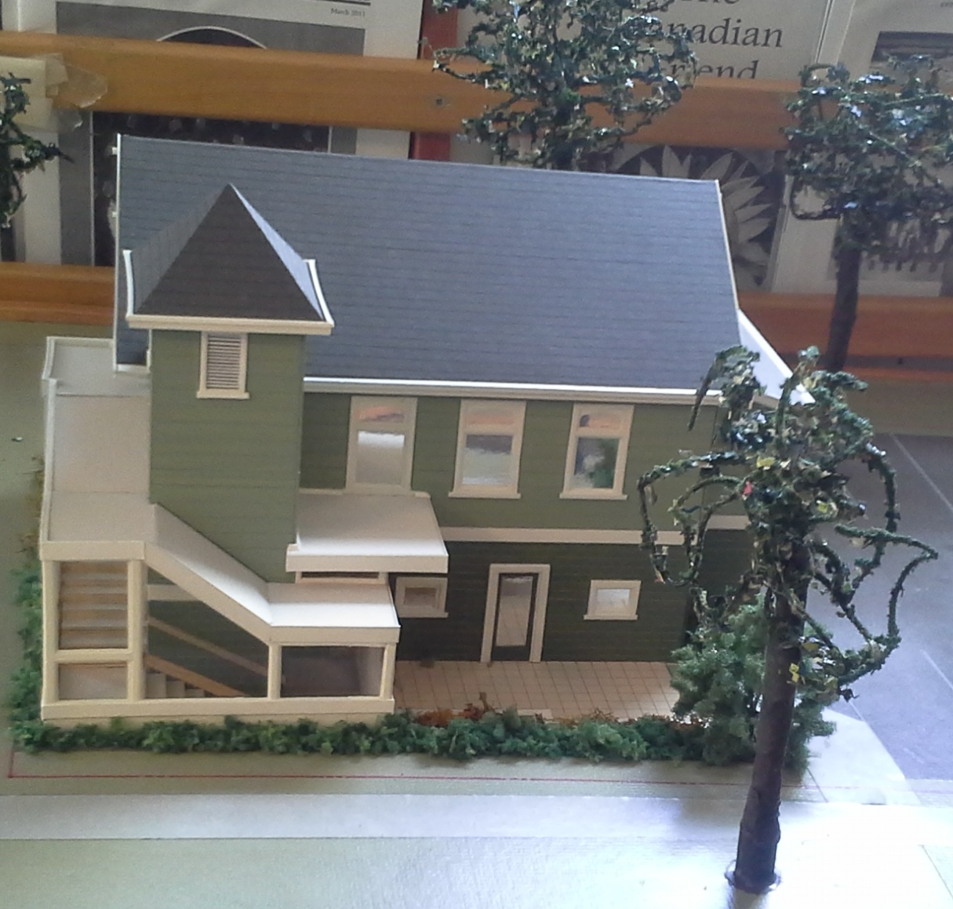
In addition to the installation of the lift and new staircase, there are some renovations planned for the downstairs, some of which will increase our amount of usable space. The office will be relocated to beneath where the new upstairs entrance will be (approximately where the Janitors closet is now located). Other changes include removal of the existing interior staircase, expansion of the kitchen by enclosing the exterior overhang to the south of the building, and relocation of the washrooms. We are considering replacing the old space heaters with a more efficient (and less space consuming!) heating system, and look forward to having interior and exterior painting and refinishing of the meeting room floor done as well.
The renovations committee, consisting of Tim, Ruth and Al, will be meeting with Brian soon to review next steps, which include getting a structural engineer involved to make sure everything we want to do can be achieved, look at proposals for the elevator installation, prepare construction documents, apply for a building permit, get quotes and eventually… start construction!
Ruth Walmsley

VAMM Library Move due to Renovations
The upcoming renovations to our meeting house will result in a move for VAMM's library. Luckily the library won't be moving very far, just a few metres down the wall from where it is now. The internal stairway located in the northeast corner of the meeting house will no longer be in use and the library will occupy that corner.
In the context of the move, committee members will review present procedures, signage, shelving, and so on in the hope of making the library easier to use. We welcome suggestions from members and attenders for suggested improvements. Suggestions can be forwarded to any member of the committee or sent by e-mail to james.turner@umontreal.ca, who will compile the suggestions and bring them to the committee for consideration.
Ruth Walmsley
Electronic Communications Committee and Mailing List Policies
Our Website Committee and ad-hoc mailing list co-ordination efforts have recently merged into a new Electronic Communications Commitee. As our first task, given to us in the March Meeting for Worship for Business, we have formalized policies for the mailing lists and sent them to both our “regular” and “occasional” mailing lists. The policies are also detailed here: http://vancouver.quaker.ca/welcome/mailing-lists/ .
Our mailing lists now use Google Groups, which means that you can subscribe yourself to them. Links to do so are in http://vancouver.quaker.ca/welcome/mailing-lists/ .
Thanks everyone for your patience during the changeover of mailing lists over the past few months.
Su-Laine Brodsky
Vancouver Monthly Meeting and Lower Mainland Worship Groups
Vancouver Meeting House: 1090 W. 70th Ave. Every Sunday, 10:30 AM, with childcare provided. First Sunday, potluck lunch. 604-263-5015. First Sunday, singing at 9:50 AM.

Fraser Valley Worship Group: meets the second and fourth First Days of each month at 10:30 a.m. at members’ homes. There will be tea and conversation after at 11:30. For information, please contact Meredith at 604-832-0954 or Meredith.egan@gmail.com

North Burnaby /Cranberry Commons Worship Group: 4272 Albert St., Burnaby. Fourth Sunday, Sept – June. Breakfast potluck at 9:30. Meeting for worship at 10:30 AM. Contact Ruth Walmsley and Tim Bartoo: 604-298-9220.
Coquitlam Worship Group: 940 Canyon Ct., Coquitlam, Third Sundays at 10:30 AM. Contact Earl Morris: 604-939-1348.
Bowen Island Worship Group: Fourth Sunday of each month. 10:40 for singing, 11:15 for worship. Followed by potluck and discussion. Contact Bev Rogers to confirm - and to arrange for pickup from ferry: 604-.947-2681
*Surrey, Sunshine Coast, and North Shore worship groups are not currently meeting. The Richmond/Steveston group has been laid down. Please see the Welcome page of Vancouver.quaker.ca for contact information.
Ongoing Events at the Vancouver Meeting House
Light Group: George Fox and the Early Friends Study Group aka the Light Group meets first Sundays after Meeting for Worship at 12:15, unless another program is planned for that time, in which case the Light Group will meet at 9 a.m. Please consider staying for an hour after Meeting (or coming early...) to discuss topics of interest to Friends.
First Day School: First Sunday beginning December 7th, during meeting. Led by Beth Lopez.
Potluck Lunch: First Sunday, after rise of meeting (Light Group participants take their food upstairs to the Meeting Room at 12:15).
Meeting for Worship with Attention to Business: Second Sunday each month, after rise of Meeting, except in summer, when one Business Meeting is held in late July covering July-August Business. All members and attenders are invited to attend.
Singing before Meeting for Worship: First and second Sundays at 9:50 am.
Newcomers Group: Third Sundays at 12:15. An opportunity for newcomers and attenders to ask questions and learn about Quaker faith and practice. Everyone is welcome.

The newsletter comes out in January, March, May, July, September, and November (odd-number months for odd, or at least peculiar, people). Deadline for submissions is in the middle of the month prior to publication of the newsletter (i.e., August 15th for the September issue). Please submit to Vancouverquakernewsletter@outlook.com or give to Yvette at the Meetinghouse. Send files as e-mail text or MS Word docs or docx, please. Announcements to MaxineKL@shaw.ca by around the 25th of the month.

