BETWEEN FRIENDS
Newsletter of the Vancouver Monthly Meeting of the
Religious Society of Friends (Quakers)
http://vancouver.quaker.ca/
January 2016
NOTE FROM THE EDITOR: The opinions expressed in this Newsletter are the opinions of the individual authors and may not reflect the opinions of the Newsletter Committee or of Quakers generally. (This applies to past, present, and future issues of Between Friends.)
Newsletter items are now to be forwarded to Vancouverquakernewsletter@outlook.com

Our Neighbours
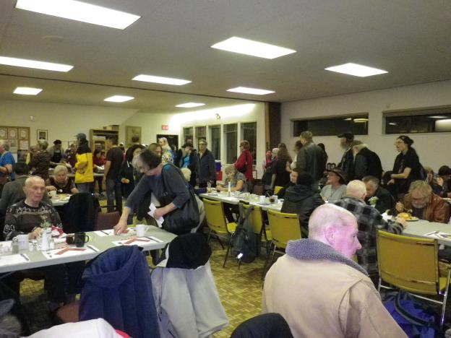
On December 2nd the Marpole Museum and Historical Society (EBURNE) held their annual Community Christmas Dinner at St. Augustine’s Church on Hudson Street, sponsored by VanCity, Marpole Branch. More than two hundred local residents participated in the feast, which included famous artists, the homeless, the handicapped, and everyone in-between. Gordon Bertram played wonderful background music with his saxophone, serenading the feasters with light jazz. The servers included board members from EBURNE, staff from Vancity, St. Augustine’s, and regular volunteers. The priest, Andrew Halliday, and his parish, are doing an awesome job in providing a space wherein local residents, not least of all seniors, can gather and participate in building community.
It enables them to network in a city that is becoming increasingly more estranged and alienating. Long
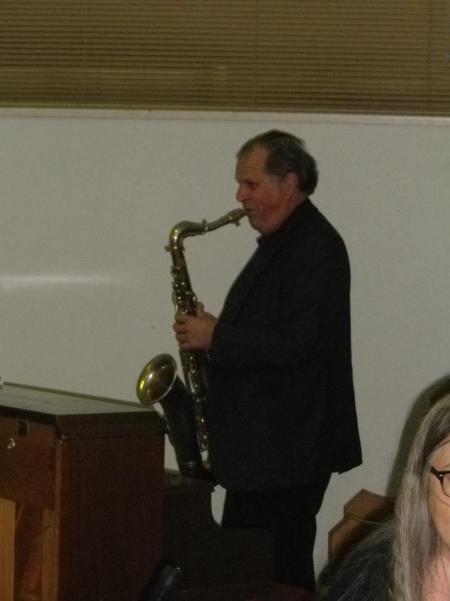
after the turkey ran out, though not the trimmings, folk were still lining up for more. The sense of community that is bubbling around St. Augustine’s Parish, which includes nonbelievers who are equally welcome, is an inspiration. No one is turned away for lack of funds at their twice-weekly meals, which are held year-round. And the homeless are not ghettoized into eating amongst themselves, but mix and mingle freely with everyone else. Our neighbours…

By Kirsten Ebsen

VaMM Friends work with Refugees
The Ad Hoc Refugee Committee has been working with the refugee committee of the Unitarian Church of Vancouver to privately sponsor and support refugees who are in most urgent need of refuge according to the UN High Commission for Refugees. Several VaMM Friends have been tutoring recent arrivals in English, and one is learning the ropes of the complicated paperwork involved in bringing refugees to Canada and helping them get settled once here. We are currently working on raising the funds needed to sponsor more refugees. The Ad Hoc Committee raised over $600 at two bake/craft sales before Christmas. We will meet in the New Year to consider how we are led to continue this work.
How to contribute to VaMM work with refugees:
Tax deductible contributions to this work can be made
by giving a cheque to the VaMM treasurer (Graham Entwistle) Meeting or mailing it to him c/o the Meeting address. To arrange for pre-authorised monthly donations, please contact Graham for instructions.
Catherine Smith and Maxine Kaufman-Lacusta

Specially called Meeting for Worship for Business
January 31 following coffee
In preparation for the upcoming Specially Called Meeting to Address CYM’s Future, please note the availability of CYM Minutes from last summer’s Sessions. Friends who do not yet have a personal password for the Business section of www.quaker.ca will need to register to gain access to the minutes, but this is easy and usually accomplished within 24 hours.
Especially relevant for our upcoming Called Meeting are the sections called “Extended worship on Visioning our Quakerism of the Future.” “Concern for a Spiritually Rich and Financially Sustainable Future.” and “Determining Priorities and Envisioning Change Working Group." They are found on page 192 and pages 212-216, 218-219 of the CYM 2015 Minutes. Additional info and links will be circulated via the VaMM email list.

Peace Brigades International is recruiting field volunteers for Colombia and Guatemala for placement in 2016 (Stipend +)
"PBI was founded by Quakers in Canada . . .. I can also answer questions, as a PBI-Canada board member and former volunteer in Guatemala. " Heather Neun
. . . The work that Peace Brigades International does is life-saving for the front-line activists and human rights defenders they accompany. It's also life changing for those who undertake this work. PBI's teams in Guatemala and Colombia are accepting calls for applications from prospective field volunteers. Deadlines are approaching quickly. Attached find a pdf, which is copied below in the text, and a graphic.
If you are not familiar with Peace Bridges International, check out the international site or PBI Canada's site for more information: http://www.peacebrigades.org/ and PBI Canada - Peace Brigades Canada - making space for peace.
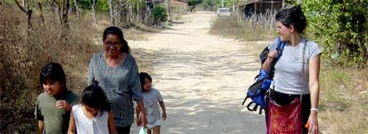 | Peace Brigades International: PBI  www.peacebrigades.org  PBI's volunteers embody international concern for human rights on the ground.
PBI Colombia Deadline to Apply: January 17, 2016
PBI Guatemala Deadline to Apply: January 25, 2016
Please note that, due to security considerations, it is a PBI policy that no nationals are eligible to apply for in-country positions in their own countries. Successful candidates serve a minimum of 12 months as a field volunteer.
BACKGROUND
Peace Brigades International (PBI) is a global non-governmental organization that has promoted non-violence and protected at-risk human rights defenders since 1981. In response to the needs of human rights defenders, we provide unarmed protective accompaniment and other support on the ground through trained field volunteers and a broad network of international support. Protective accompaniment deters attacks against human rights defenders by sending a powerful message that the world is watching and prepared to act. Integral to PBI’s protection strategy are political support networks that can be activated by our 16 country groups in North America and South America, Europe, and Australia. These country groups, including PBI-Canada, are also responsible for volunteer recruitment, outreach, advocacy, and fundraising. PBI is an independent, volunteer-driven and consensus-based organization not affiliated with any religious or political institution. We are non-partisan and do not interfere in the work of those we accompany. To learn more visit: http://www.peacebrigades.org/

PBI FIELD VOLUNTEERS
To become a PBI field volunteer is an incredible, career-making opportunity to provide protective physical and political accompaniment to at-risk human rights defenders (HRDs) and communities. By doing so you will help to deter violence and create space for defenders to continue their critically important work toward peace, justice and human rights.
PBI volunteers acquire a broad range of experience, from engaging directly with human rights defenders, to providing capacity-strengthening training on HRD protections and digital security, undertaking research and analysis, monitoring and evaluation, writing communications materials, project management, and advocacy with the diplomatic corps, national authorities and others.
Specialized training, return flights, room and board, medical insurance, monthly stipends and a repatriation grant are provided to volunteers.
Please review the requirements and application procedures for the country to which you wish to apply, and contact the project in that country directly with any questions. If you are selected for training, please contact PBI-Canada. PBI-Canada may be able to offer some travel support and assistance with fundraising to attend training (volunteer@pbicanada.org).

PBI COLOMBIA APPLICATION INFORMATION
PBI field volunteers in Colombia are placed in a team in Bogotá, Barrancabermeja, or Urabá, accompanying human rights defenders and communities. PBI Colombia usually holds only one training and selection process per year for prospective field volunteers.
Deadline to apply: All applications (with references) must be received by January 17, 2016 . The training will take place in Spain (date TBD, during the last quarter of 2016)
To learn more and to access the necessary forms, please visit: http://tinyurl.com/PBI-Colombia-Volunteers-2016. Visit the PBI Colombia website to learn more about the project and the human rights defenders its volunteers accompany: http://pbicolombia.org/ .

PBI GUATEMALA APPLICATION INFORMATION
PBI’s field team in Guatemala is based in Guatemala City. PBI Guatemala usually has two selection and training sessions per year for prospective field volunteers. Deadline to apply: All applications and reference forms for this first selection/training process must be received by January 25, 2016.
The training will take place from May 29-June 4, 2016 in Belgium
To learn more and to access the necessary forms, please visit: http://tinyurl.com/PBI-Guatemala-Volunteers-2016 . Visit the PBI Guatemala website to learn more about the project and the human rights defenders its volunteers accompany: http://www.pbi-guatemala.org/

No January 2016 VaMM Directory Update, but. . . .
- Please remove Al Mytcowicz's cellphone number
- Please note that Karen Hertz's gmail address is replaced by [same as before]@yahoo.com

Representative Meeting - doing Canadian Friends' business
outside of the annual** CYM-in-session gathering
Some highlights of the 2015 session of Representative Meeting
The Minutes of Representative Meeting, held November 27 and 28, 2015 should soon be available on quaker.ca (Business section - under Documents/RM Docs). If you don't have an individual password yet (the universal one is no longer valid), you will need to request one at the site. A copy of the minutes and reports will also be pinned to the Meetinghouse bulletin board for perusal by Friends without Internet access.
Meanwhile, here are a few highlights (mostly from items not dealt with in the upcoming minutes - exceptions are marked with *) of this meeting, which I attended as representative for VaMM. I'll begin with a few bits of news from representatives of other meetings, followed by items of business that I think may be of particular interest to Vancouver Friends. And in case your new to all this, and wonder just who and what Representative Meeting is, at the end of this article I've appended the portion of the report of Discipline Review Committee - a revision to Organization and Procedure clarifying this.
Highlights of the Friday evening go-round
of what various MMs and committees are up to: a few that especially caught my attention***
REFUGEE SPONSORSHIP:
Like VaMM, several Meetings are involved in refugee sponsorship activities (Syrian and other), some of it longstanding. One example is Coldstream MM, which has been helping Somalian refugees for the past ten years and is now supporting an Iraqi Kurdish refugee along with other groups. A Lebanese member/attender of the Meeting has been selling home-baked pies and donating the profits– approaching $1,000 - to this project. Another is Pelham Executive Meeting in Ontario, which will be cosponsoring a Syrian refugee family with local mosque. This connection was initiated by a Mennonite minister who sometimes worships with the Meeting.

OTHER INTERFAITH WORK:
Besides hosting the Youth and Militarism Conference this year (which it plans to do again), Peterborough MM has formed a Peace Council with other local churches, which now holds a monthly peace vigil. The MM has also been doing a bit of outreach to Muslim neighbours since the recent bombing of a Peterborough mosque.

NEW BOOK:
Ottawa MM member and longtime peace and anti-nuclear activist Murray Thomson has recently published a new book, described in this post from the CFSC facebook page: A nice little article including a bit about the activism of Friend Murray Thomson, whose new book, "Minutes to Midnight: Why more than 800 Order of Canada recipients call for Nuclear Disarmament" has been supported by Ottawa Meeting and through a CFSC individual grant
http://www.embassynews.ca/news/2015/…/28/peacemakers/47786/?mlc=961&muid=22725

PEACE QUEST:
Thousand Islands MM (Kingston, ON) is becoming a PeaceQuest Faith Community. For more information about this movement, see http://peacequest.ca/about-us/ or contact TIMMclerk@quaker.ca .

FRIENDS TESTIMONIES AND QUAKER ORAL HISTORY:
Friends in Winnipeg MM are doing a study program focusing on one testimony each 3 months except in summer, with study and action components. Currently on Integrity. Will focus on Climate Change in winter. Winnipeg Friends are involved in a long-term oral history project on Friends in Manitoba: “What Canst Thou Say” – for the Archives of Manitoba, initiated by an MA student at the School of Oral History at the University of Manitoba.
*** If you would like a copy of my 3 pp of rough notes on the whole go-round, just drop me a request at MaxineKL@shaw.ca, with Go-round in the subject line or phone me for a hard copy.

Representative Meeting business of possible interest to VaMM Friends
EDUCATION AND OUTREACH aka E&O (formerly Home Mission and Advancement Committee/HMAC) - The following 4 items are excerpted or paraphrased from the E & O report:
E& O are concerned about the dwindling attendance of families and Young Friends at Yearly Meeting. They have budgeted up to $20,000 to assist folks for whom cost is a barrier to attendance, with a maximum of $1500 for any one family. (Note from MKL: This is in addition to existing funding of up to $720 per family from CYM itself, bringing the total maximum grant per family to $2,220)
In addition, there is still $6401.56 available in the Youth Challenge Fund from 2013 for use in 2016.
The YES [Youth Engagement] subcommittee of E&O will plan two youth gatherings in 2016 – one at the Eco-Village on Vancouver Island, and one in Ontario. This subcommittee is also working with CYFYM to revamp ‘Sporadical’ – the Canadian Young Friends’ newsletter – into a website blog at Sporadical.ca which will contain blogs, a forum, an events bulletin board, a book club, etc. This will be the new social site for Canadian Young Friends Yearly Meeting. CYFYM minutes and business will be posted on quaker.ca/youth.
Meeting for Worship for Business Subcommittee of E & O. . . [At CYM 2015 this committee offered] a Special Interest Group (SIG) on Recording with an Attention to Business which was well received and requested again for CYM 2016. The subcommittee plans to create a template for conducting a short workshop on the conduct of meeting for worship for business which can be offered to local meetings.
Outreach: Friends Journal has given us permission to use their ‘Quaker Speak’ videos in any way. Some will be placed on the CYM website. (Note from MKL: I have also been forwarding links to these occasionally to Friends on my "Quaker Forwards" e-list.)

* Thinking about changing CYM-in-Session Week (formerly call the Bold New Plan/BNP): There wasn't unity regarding sharing the "BNP document" in its present form with Meetings, so watch for further information on this. Meanwhile, it is hoped that MMs will discuss if and how they would like CYM-in-session to change, and get feedback to the clerks' committee by June 30 for further discernment and decision at CYM 2016. CYM clerk Elaine Bishop expressed her sense that it is essential "to delve beneath any specific format for CYM week, whether the one we currently have, the Bold New Plan or any other, to the foundations upon which any format is designed."

Vancouver MM will be holding a specially called M4W4B on this topic on January 31 (see page 4).

*TREASURER'S REPORT (short version): We're doing better financially than we were, but "we can't rest on our laurels." The 2016 budget was approved, but we were cautioned that we need to continue to increase donations and/or find ways to significantly reduce expenses to continue operating at present levels. The Clerk of Contributions Committee thanked Friends for generosity in increasing their contributions to CYM and those who are part of the process and requested suggestions for raising additional funds.

REPORT FROM THE EVENING AT CANADIAN YEARLY MEETING (CYM) 2015 facilitated by Education and Outreach (E&O) Committee and Publications and Communications (P&C) Committee – is full of interesting bits of information about Friends' use (and non-use) of quaker.ca and other related topics. Please see the full report once it is posted on Quaker.ca and our bulletin board.

*PUBLICATIONS AND COMMUNICATIONS COMMITTEE REPORT: Friends will have noticed that The Canadian Friend is now coming out only twice a year, due to cost concerns. You are also reminded that you can opt out of receiving the print edition, in which case you can read it on line or download the PDF of the current and past issues. If you haven't yet done so, and wish to, please contact MaxineKL@shaw.ca (this is one of the pieces of information that I forward to Kerry at the CYM office when I send her updates to our directory.
Also, P &C would like to know whether Friends would like them to increase publication of CF during the "fallow year" of 2017 (i.e., when there will be no CYM gathering in August). This would cost $5,500 per additional issue.
Good news! The CYM Directory is going to be re-instated - though not in a print edition - in the password-protected Business/private area of the website as a PDF. You will have to again provide permission to be listed, and instructions for revoking this permission will be made available. Hopefully, a letter clarifying this will soon be circulated to MMs.

PROGRAMME COMMITTEE: "Programme Committee continues to receive and holds concerns about the lack of tenting and Food Coop, which raises the cost for Friends and especially families of attending YM. We continue to treat this as an important criterion for sites for future Yearly Meetings and regret that such sites are increasingly difficult to find. CYM 2016 in Camrose Alberta Yearly Meeting will be August 5-13 at Augustana College in Camrose AB. This site is familiar to us from several rotations now, and does allow both tenting and Food Coop. We are happy to announce that Maggie Knight will be our SPG Lecturer, and Kate Johnson our Bible Study Leader.
SPG lecture in 2017 - In the absence of a CYM gathering in 2017 ("fallow year" to cut costs), Programme Committee has arranged for the Sunderland P. Gardner lecture to be held at Spring Western Half-Yearly Meeting in May. Friends are asked to suggest names of possible SPG lecturers.

*From the Report of the DISCIPLINE REVIEW COMMITTEE (changes to Organization and Procedure approved at Representative Meeting 2015)
6.4 Representative Meeting -
Representative Meeting consists of:
- a representative from each Monthly Meeting of Canadian Yearly Meeting;
- a representative from each Quarterly Meeting and Half Yearly Meeting of Canadian Yearly Meeting, if they wish;
- the Clerk(s) of Yearly Meeting, who serve as Clerks of Representative Meeting as well;
- the Representative Meeting Recording Clerk(s);
- the clerks, or a representative, of Yearly Meeting standing committees;
- the clerks, or a representative, of other Yearly Meeting bodies (Trustees, Continuing Meeting of Ministry and Counsel) [and Canadian Young Friends Yearly Meeting, as Bruce Dienes pointed out.)
- the Treasurer of Yearly Meeting.
And NOTE: It is now official (6.2 of the DRC Report):
"The Clerks of Yearly Meeting also serve as Clerks for Representative Meeting."
___________________________
**NOTE: In 2017 there will be an additional (second Representative Meeting Session to deal with business that would have come to CYM in session - which will not take place that year. This will include an "intergenerational" day in Toronto with Young Friends following their CYFYM at Nee-Kau-Nis, after which many from both groups will travel to FGC (Friends General Conference gathering) July 2-8, 2017 in Niagara Falls, NY. So if you're planning to be in the East around that time, save that date (and start saving up for this somewhat pricy but very worth-while gathering)!
Vancouver Monthly Meeting and Lower Mainland Worship Groups
Vancouver Meeting House: 1090 W. 70th Ave. Every Sunday, 10:30 AM, with childcare provided. First Sunday, potluck lunch. 604-263-5015. First and second Sunday, singing at 9:50 AM.
Fraser Valley Worship Group: meets the second and fourth First Days of each month at 10:30 a.m. at members’ homes. There will be tea and conversation after at 11:30. For information, please contact Meredith at 604-832-0954 or Meredith.egan@gmail.com .
North Burnaby /Cranberry Commons Worship Group: 4272 Albert St., Burnaby. Fourth Sunday, Sept – June. Breakfast potluck at 9:30. Meeting for worship at 10:30 AM. Contact Ruth Walmsley and Tim Bartoo: 604-298-9220.
Coquitlam Worship Group: 940 Canyon Ct., Coquitlam, Third Sundays at 10:30 AM. Contact Earl Morris: 604-939-1348.
Bowen Island Worship Group: Fourth Sunday of each month, 10:45 am in the sanctuary at Rivendell retreat centre. Contact Bev Rogers (604 947 2681) to get picked up at the ferry.
*Surrey, Sunshine Coast, and North Shore worship groups are not currently meeting. The Richmond/Steveston group has been laid down. Please see the front section of the current Vancouver MM Directory or the Welcome page of Vancouver.quaker.ca for contact information.

Ongoing Events at the Vancouver Meeting House
Light Group: George Fox and the Early Friends Study Group aka the Light Group meets first Sundays after Meeting for Worship at 12:15, unless another program is planned for that time, in which case the Light Group will meet at 9 a.m. Please consider staying for an hour after Meeting (or coming early...) to discuss topics of interest to Friends.
First Day School: First Sunday, during meeting. Led by Beth Lopez.
Potluck Lunch: First Sunday, after rise of meeting (Light Group participants take their food upstairs to the Meeting Room at 12:15).
Meeting for Worship with Attention to Business: Second Sunday each month, after rise of Meeting, except in summer, when one Business Meeting is held in late July covering July-August Business. All members and attenders are invited to attend.
Singing before Meeting for Worship: First and second Sundays at 9:50 am.
Newcomers Group: Third Sundays at 12:15. An opportunity for newcomers and attenders to ask questions and learn about Quaker faith and practice. Everyone is welcome.
The VaMM newsletter comes out in January, March, May, July, September, and November (odd-number months for odd, or at least peculiar, people). Deadline for submissions is in the middle of the month prior to publication of the newsletter (i.e., February 14 for the March issue). Please submit to Vancouverquakernewsletter@outlook.com or give to Yvette at the Meetinghouse. Send files as e-mail text or MS Word doc or docx, please. Announcements to MaxineKL@shaw.ca by around the 25th of that month.

