BETWEEN FRIENDS
Newsletter of the Vancouver Monthly Meeting of the
Religious Society of Friends (Quakers)
http://vancouver.quaker.ca/
March 2016
NOTE FROM THE EDITOR: The opinions expressed in this Newsletter are the opinions of the individual authors and may not reflect the opinions of the Newsletter Committee or of Quakers generally. (This applies to past, present, and future issues of Between Friends.)
Newsletter items are now to be forwarded to Vancouverquakernewsletter@outlook.com

How and Why I am A Quaker
Vancouver Meeting is starting a new event entitled How and Why I am a Quaker. This will be a brief presentation given by a Friend, at the start of Meeting for Worship with Attention to Business, held once a month. Each month a Friend will be asked by Ministry and Counsel (M&C)to share their personal Quaker journey with the rest of us. They will be given two to three weeks to prepare a presentation, which will run eight to ten minutes in length.
There will be no judgment and we do not clap afterwards. Nor is it a competition. Nor will we discuss the presentation, though one can express one's appreciation privately afterwards. This is a popular practice that has been held at Westminster Meeting for many years. Amazing how much one can learn about Friends one thought one knew well. It will take our knowledge and understanding about each other to a deeper level, helping us to bond into a closer community. It can also help, over time, to dispel a sense of marginalization for those Friends who might feel excluded.
It's a wonderful way to get to know Friends who live further afield and who are willing to come to Meeting to give such a presentation, thereby connecting us more closely with Friends from other worship groups, and who we don't see often at Vancouver Meeting. And for them to get to know us better. Also, for newcomers who have recently arrived in Vancouver from other meetings. It's a great exercise for those who are shy about speaking in front of a group: what can be a safer setting in which to present oneself than among Friends? Viola! The shyness disappears. One doesn't have to be a Member to give this presentation, but must have shown a commitment to Quaker faith and

practice. Nor is one's personal perception and understanding of the Divine a deciding factor in being asked to present. The upcoming speaker will be announced in advance after Meeting for Worship
two weeks prior to the presentation, and again one week before, by members of M&C. This will give Friends an opportunity to plan to be present, if they so wish.
Vancouver Meeting has agreed to a four-month trial period to see how it goes. It's important for the speakers to prepare so as not to run past the ten minute mark; discipline is involved. Friends who are asked to speak usually feel honoured to do so, despite possible butterflies because it's a personal bio-in-brief; one cannot share everything. The focus is on highlights one wishes to share from one's own personal experience and practice. In the short term, we will get to know four Friends better in the next four months. In the long term, if it flies, we will get to know eleven Friends on a deeper level every year, beyond our normal socializing and silent worship sharing. I, for one, hope it will fly. Having experienced this in the UK, I can only say how joyful and enriching this exercise is for all.
In Friendship,
Kirsten Ebsen
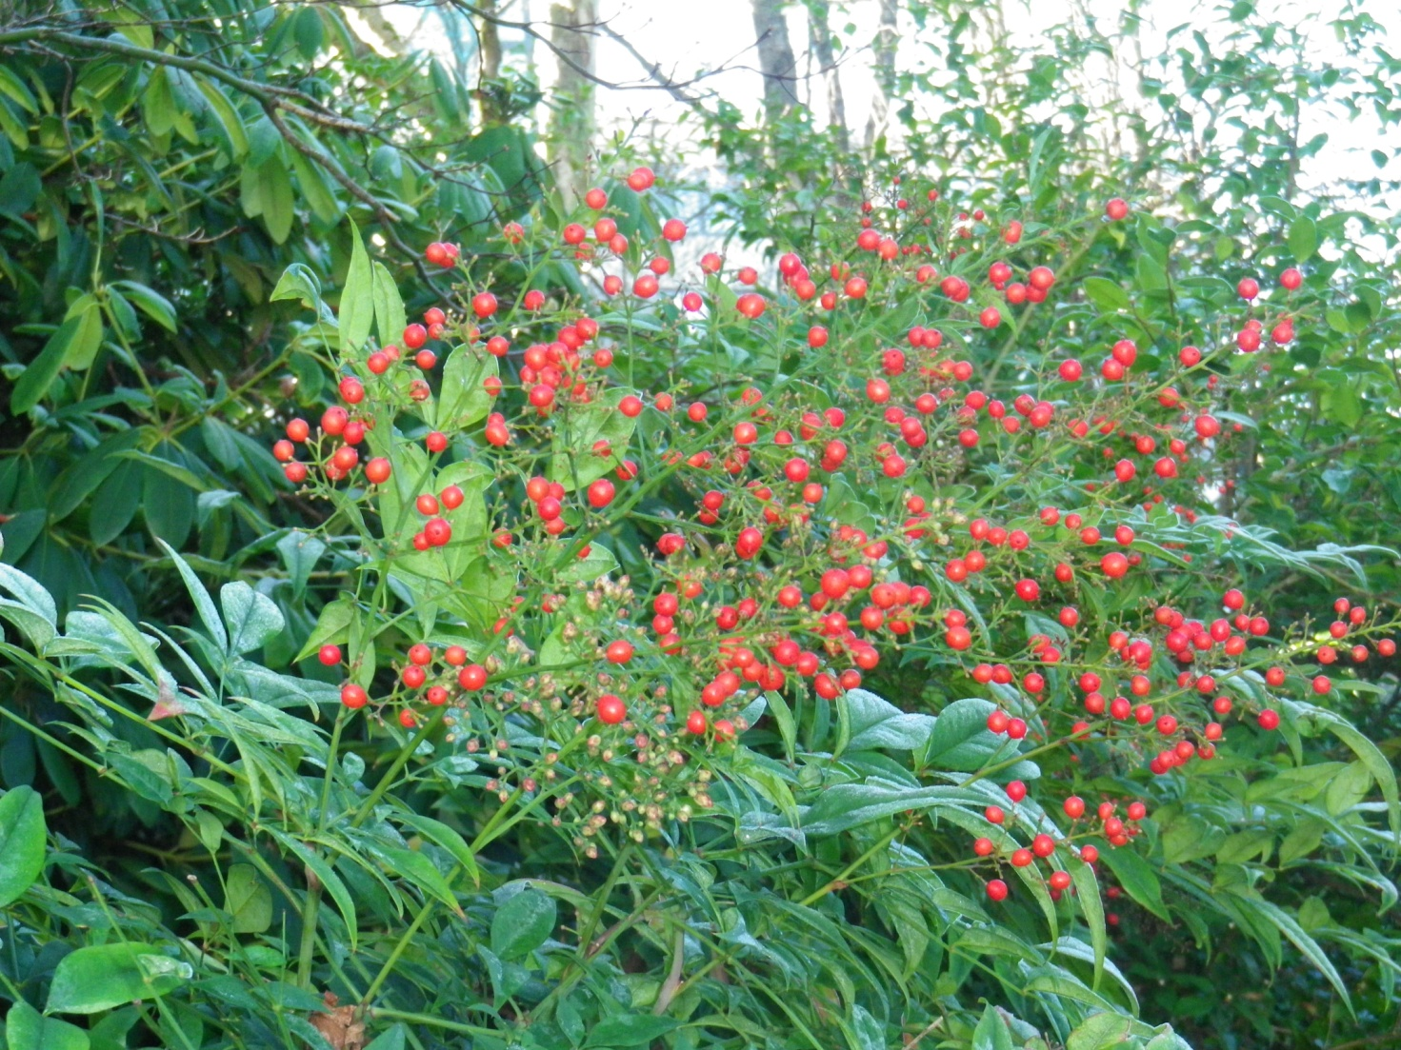

Western Half Yearly Meeting
Coming soon (May long weekend) to Sorrento, BC , Spring Western Half-Yearly Meeting is as close as a largish Quaker gathering has gotten to the Lower Mainland in many years. Preceded by a day of balancing and including a little business and a lot of getting-to-know-each-other activities, worship, and special interest groups, WHYM is an ideal way to "test the waters" for those new to Friends who are wondering about attending the more-densely programed Yearly Meeting gathering (CYM) in August, as well as a much looked forward to event for "oldtimers." Links to registration materials will be circulated on the VaMM e-announcement list when they become available - and will be mailed to Friends without internet access who request this (call or text Maxine at 604-444-4690). Some printed copies will be brought to the Meetinghouse as well. Meanwhile, you might want to join the Western Half Yearly Meeting Facebook Group

Western Half Yearly Meeting meets twice a year, May in Sorrento, B.C. and October on the Prairies.
The Fall meeting on the Thanksgiving weekend alternates between sites in Saskatchewan and Alberta but on the Spring long weekend it is always at the Sorrento Centre. Friends from Ontario to Vancouver Island to the North and everywhere between travel to WHYM to gather for fellowship and worship.
WHYM is an intergenerational community with programs for everyone; folks attend from every age group, including young children, teens, and elders. All the treasured WHYM traditions of balancing, singing, campfires by the lake, rides on the “Flying Fox” zip line, Worship Fellowship, Special Interests and Meetings for Worship and Business, provide the context for us to learn, make new friends and renew our bonds with one another (from Quaker.ca/what-we-do/gatherings/ )

News from the VaMM Library Committee
LibraryThing app
iPhone, iPad, and iPod Touch users can now browse and search the VaMM library catalogue, as well as other Quaker library catalogues that are on LibraryThing, via an app that was published recently. The app is called LibraryThing and is available from the iTunes Store. There is no cost. The app takes up 5.7 MB of space, and requires iOS 8.0 or higher. For the moment, the app is available only for Apple devices. However, an Android version is in the works, although no delivery date has been announced.

Easier access to pamphlets
A while back, the Library Committee decided to catalogue two pamphlet series because of the importance of the contents of these series. These are the Canadian Quaker Pamphlets and the Pendle Hill Pamphlets. Until now, the pamphlets were not catalogued individually, with the exception of fewer than ten titles that were catalogued as books.
Work has now begun on this project. The main advantage to users is that the pamphlets become searchable in the online catalogue. Special call numbers are assigned to these series, that are outside the simplified Dewey call numbers used for books. For the Canadian Quaker Pamphlets, the acronym CQP is used, followed by the pamphlet number. For the Pendle Hill Pamphlets, the acronym PHP is used, followed by the pamphlet number. For example, Canadian Quaker Pamphlet number 30 has the call number CQP 030 and Pendle Hill Pamphlet number 264 has the call number PHP 264. To accommodate this, alongside the "Dewey/Melvil" column with the call numbers for books that already appears in the LibraryThing online catalogue, another column entitled "Other call number system" has been added.
Users can look at a list of all of the pamphlets we have in either series simply by typing either CQP or PHP into the search box. In addition, searches for particular subjects will now bring up the pamphlets dealing with the subject, along with the books that have the same subject. Users can also find pamphlets by searching the author's name, or any word in the title.
We are also adding labels to the pamphlets, showing the new call numbers. The pamphlet number often appears on the cover, but it is not always in the same place nor necessarily easy to find, so the labels should make finding a particular pamphlet easier.

Q and A with youth climate justice activist and Quaker, Maggie Knight
http://greeningsacredspaces.net/q-and-a-with-youth-climate-justice-activist-and-quaker-maggie-knight/
“Today, it’s a belief in justice, rooted in science, faith, and community, that motivates me to act.” Maggie Knight, Climate Justice Activist.
Maggie Knight is a member of Fossil Free Faith. She hails from unceded Coast Salish territory in Victoria, BC, and has been speaking up for climate justice since her teens. She now works with RADIUS at Simon Fraser University, collaborating with social innovators to build a new economy that’s just, sustainable, and healthy for all.
Maggie Knight. Photo by Caelie Frampton
You are a member of Fossil Free Faith. Can you tell us a little about why you joined this group? That is, what motivates you to engage in the eco-and social justice movement and how does this tie in with your faith?
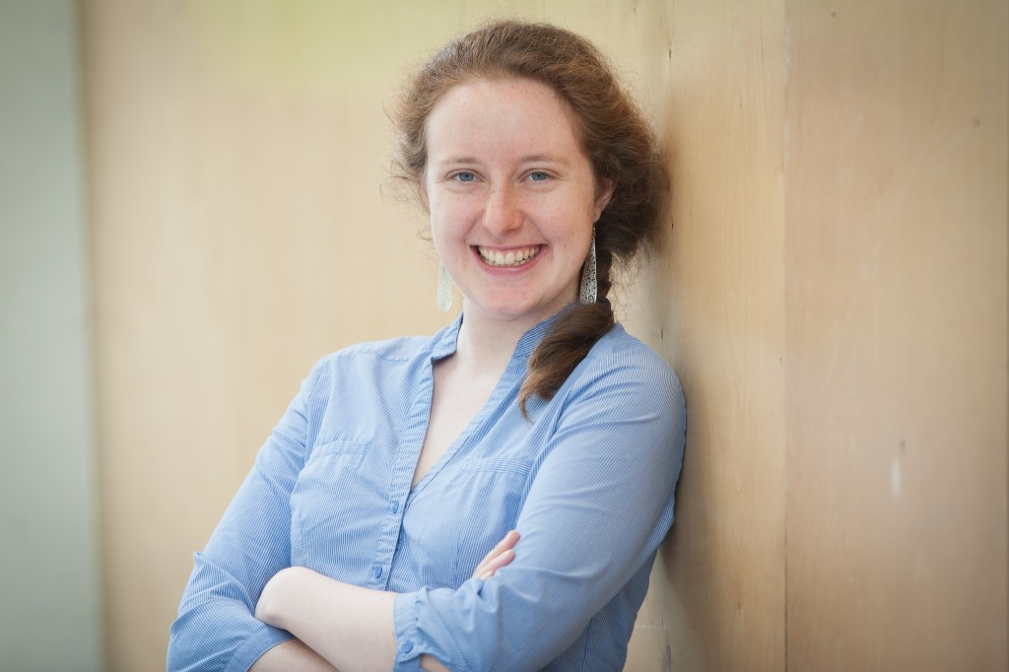
I was just getting settled into living in Vancouver when Christine Boyle and I went for lunch and she mentioned her plans for the Fossil Free Faith Fellowship. I grew up on unceded Coast Salish territory in Victoria, but had lived in Montreal for five years and Halifax for two before coming back to the West Coast. I was used to being fairly private about my faith, but I found myself having many more conversations about what it meant to be a Quaker in the lead up to my wedding (I married my long-time partner in July 2015).
I was ready to lean into the connection between my decade of climate and social justice activism and my faith, and I wanted to connect with other young people of faith and to learn about how their faiths motivate them to act.
I grew up near the ocean, and my initial environmental activism as a teen was focused on environmental protection initiatives like reducing waste and overconsumption and protecting the trees in my neighbourhood through a revised bylaw; simultaneously, I was passionate about human rights and peace building. As I grew up, my understanding of both peace and environment deepened, and became rooted in justice. Environmental stress is a major cause of conflict, and conflict causes incredible environmental devastation – and of course climate change has many complex justice dimensions, domestically, globally, and intergenerationally. In university, I studied environmental science, policy, and economics to further learn about these complexities.Today, it’s a belief in justice, rooted in science, faith, and community, that motivates me to act.
Have you always seen the connection between your faith and climate justice?
Quakers have a long tradition of activism on social and environmental fronts, so when I became involved with Friends (the formal name for Quakers is the Religious Society of Friends) as a teenager I was surrounded by many examples of people who lived out their values through their activism. Quakers are guided by testimonies of Simplicity, Peace, Integrity, Community, Equality, and Earth Stewardship, and in worship we gather in silence and listen inwardly for divine guidance, sharing spoken ministry out of the silence if we “feel so led”.

I think I have always understood my faith to be rooted in seeking how best to live according to your values and offer what you can to the world. This ongoing seeking and discernment for one’s path forward calls on your knowledge of the world, including the science and effects of climate change. In this sense, there has always been a connection between faith and climate justice.
How is your activism perceived by your faith community, your peers?
Photo by Tori Ball
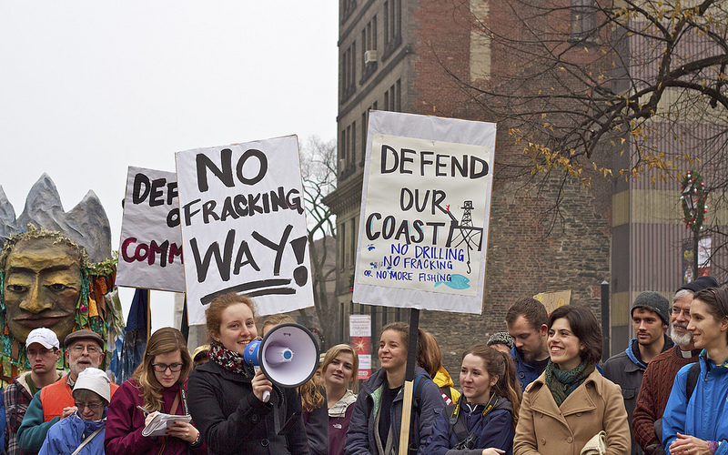
I’m lucky to have a very supportive faith community that has encouraged me in activism over the years. I’ve learned a lot from older Friends and been financially supported to attend events and undertake projects; I’m just starting to be able to give back in kind. Quakers can see this kind of work as a spiritual “leading” that may be supported by the community.
I’ve made many good friends through climate justice organizing, and I’m lucky to have a group of friends who support my activism even if it’s not always the path they choose for themselves. Especially early on I’d sometimes end up in arguments about the facts of climate science with peers who believed climate denier arguments, but that’s much less common these days as public awareness and climate science literacy has improved..
What are you plans moving forward for climate action?
To me, the movement for climate justice is a lifelong effort. At the moment, I’m exploring interfaith climate justice work through the Fossil Free Faith Fellowship, connecting with faith communities about how their spiritual beliefs and religious practices call them to action.
After about 7 years of full-steam-ahead climate activism (from my mid-teens through my undergrad at McGill), I rolled back my volunteer commitments to focus on two major roles. First, I was elected president of McGill’s undergraduate student union and was in office during the 2011-2012 Quebec student strike. When my term as student president ended, I joined the young political advocacy start-up Leadnow.ca and ended up Managing Director, throwing myself into building a progressive political organization that could mobilize hundreds of thousands of Canadians for a fair economy, a deeper democracy, and climate justice.
A little over a year ago, it was time for me to recover after over 3 years of sprinting and take a step back to be fully present as my partner and I celebrated our marriage. (After being part of an activist culture of overwork for a long time, I still feel a little uncomfortable saying that – but I also believe that we need to lift up better boundaries so more people can commit to climate justice work for the long haul.) I’ve been working with RADIUS, a social innovation lab and venture incubator at Simon Fraser University, collaborating with innovators to transform our economy to be just, healthy, and sustainable for all.
I’ve contributed to some anti-racism and pro-democracy organizing efforts on a small scale (both of which I see as deeply related to climate justice work) and I’ve been enjoying learning from the other Fossil Free Faith Fellows. I’m enjoying this time of reflecting on how I am led to organize for climate action through faith (in addition to speaking through the language of science, economics, and movements), and looking forward to jumping in with both feet again soon.

About Maggie Knight
After years of climate activism with the Sierra Youth Coalition, Canadian Youth Climate Coalition, and others, Maggie served as President of McGill’s undergrad student union during the Quebec student strike and as political advocacy non-profit Leadnow.ca’s first Managing Director. Less publicly, she’s a Quaker – a religious tradition grounded in testimonies of simplicity, equality, integrity, community, and peace. Quakers worship in silence, each inwardly listening for divine guidance; with no priest or preacher, all gathered are welcome to give spoken ministry if they feel “led.” Maggie has learned from Quaker elders who have worked for justice for decades, from the front lines of the civil rights movement to standing up for Indigenous rights in James Bay. Maggie believes that faith communities have a powerful role to play in articulating the moral imperative for climate justice and leading by example.
Praying for Peace, Paying for War?
Conscience Canada (ConscienceCanada.ca) has made it super simple to follow your conscience if you are led not to pay for "war and preparation for war."
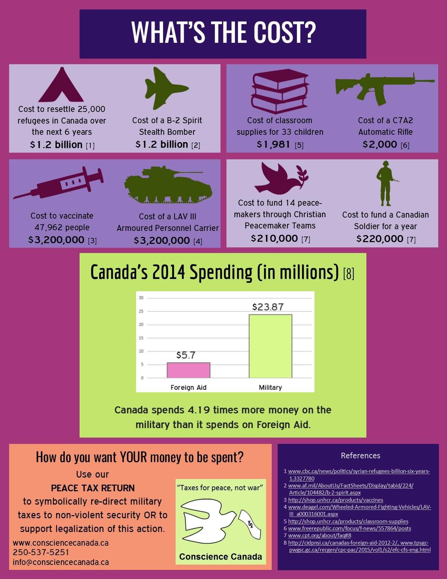
An E-Peace Tax Return can be found at http://www.consciencecanada.ca/eptr , but for those of you who still file a paper return, there is also a PDF version that you can download and print out for inclusion with your return.
Both formats include a letter to the minister of finance, which you can use as is, or adapt to your own needs, as well as options allowing you to choose either redirecting all or part of the "Defense" portion of your taxes owing to the Conscience Canada Peace Tax Trust Fund - or simply registering your objection to military spending.
For the former, Conscience Canada explains:
"This form is for those who object to military spending on grounds of conscience or principle and wish to declare their objection to the Canadian government. Although this is not an official Income Tax and Benefit Return form, it is not an offense to use it, and we are not aware of any criminal charges against any of the 1,000+ Canadians who have expressed conscientious objection to military taxation since Conscience Canada began in 1978. For information on likely consequences, please see our website www.consciencecanada.ca."
Maxine Kaufman-Lacusta (a member of the CYM War Tax Concerns Committee)

Vancouver Monthly Meeting and Lower Mainland Worship Groups
Vancouver Meeting House: 1090 W. 70th Ave. Every Sunday, 10:30 AM, with childcare provided. First Sunday, potluck lunch. 604-263-5015. First Sunday, singing at 9:50 AM.
Fraser Valley Worship Group: meets the second and fourth First Days of each month at 10:30 a.m. at members’ homes. There will be tea and conversation after at 11:30. For information, please contact Meredith at 604-832-0954 or Meredith.egan@gmail.com
North Burnaby /Cranberry Commons Worship Group: 4272 Albert St., Burnaby. Fourth Sunday, Sept – June. Breakfast potluck at 9:30. Meeting for worship at 10:30 AM. Contact Ruth Walmsley and Tim Bartoo: 604-298-9220.
Coquitlam Worship Group: 940 Canyon Ct., Coquitlam, Third Sundays at 10:30 AM. Contact Earl Morris: 604-939-1348.
Bowen Island Worship Group: Fourth Sunday of each month, 10:45 am in the sanctuary at Rivendell retreat centre. Contact Bev Rogers (604 947 2681) to get picked up at the ferry.
*Surrey, Sunshine Coast, and North Shore worship groups are not currently meeting. The Richmond/Steveston group has been laid down. Please see the front section of the current Vancouver MM Directory or the Welcome page of Vancouver.quaker.ca for contact information.
Ongoing Events at the Vancouver Meeting House
Light Group: George Fox and the Early Friends Study Group aka the Light Group meets first Sundays after Meeting for Worship at 12:15, unless another program is planned for that time, in which case the Light Group will meet at 9 a.m. Please consider staying for an hour after Meeting (or coming early...) to discuss topics of interest to Friends.
First Day School: First Sunday of each month during meeting. Led by Beth Lopez.
Potluck Lunch: First Sunday, after rise of meeting (Light Group participants take their food upstairs to the Meeting Room at 12:15).
Meeting for Worship with Attention to Business: Second Sunday each month, after rise of Meeting, except in summer, when one Business Meeting is held in late July covering July-August Business. All members and attenders are invited to attend.
Singing before Meeting for Worship: First and second Sundays at 9:50 am.
Newcomers Group: Third Sundays at 12:15. An opportunity for newcomers and attenders to ask questions and learn about Quaker faith and practice. Everyone is welcome.
The VaMM newsletter comes out in January, March, May, July, September, and November (odd-number months for odd, or at least peculiar, people). Deadline for submissions is usually between the 15th and 20th of the month prior to publication (e.g., April 15th or thereabouts for the May issue). Please submit to Vancouverquakernewsletter@outlook.com or give to Yvette at the Meetinghouse. Send files as e-mail text or MS Word docs or docx, please. Announcements of events to take place over the period covered should be given to Maxine or sent to MaxineKL@shaw.ca by around the 25th of the month prior.

