BETWEEN FRIENDS
Newsletter of the Vancouver Monthly Meeting of the
Religious Society of Friends (Quakers)
http://vancouver.quaker.ca/
May 2015
NOTE FROM THE EDITOR: The opinions expressed in this Newsletter are the opinions of the individual authors and may not reflect the opinions of the Newsletter Committee or of Quakers generally (This applies to past, present, and future issues of Between Friends).

Newsletter items are now to be forwarded to Vancouverquakernewsletter@outlook.com

Dare not to tell such a tale of meeting house stillness.
Why ?...Mice don't even live there,
And it looks like nothing else does either!
But looks are deceiving.
Packed all around is everything needed in case of need,
But, not all at once.
Welcome to 'Round the Kitchen Table' and introduction into the ins and outs of the actual building and some of its idiosyncrasies
TODAY'S TOPIC ... Where are things?
I am there ALL alone!
-main water shut off...washroom nearest the lower door entrance-right...there on a pipe stand little lower than knee height.
- oh...no bathroom tissue in washroom cabinet ?..check janitorial closet
which you will find right before the office door.. here you will also find seasonal supplies and cleaning preparations.
Warning:- for the brave only
New members -and you don't have to be new- are asked to guess where the hot water tank and the fuse box are to be found.
Looking forward to the next time to check out our stove, refrigerator and meagre pantry.
By Al bldg&grnds
First Day School
There will be First Day School on May 3rd. The children will hear from Rob Hughes who will explain something about the KAIROS Truth and Reconciliation project. They be preparing and painting wooden hearts. Children from across the country are invited to submit a heart. One of ours will be sent to Ottawa, to the project.

AGLI (African Great Lakes Initiative): an appeal for participants
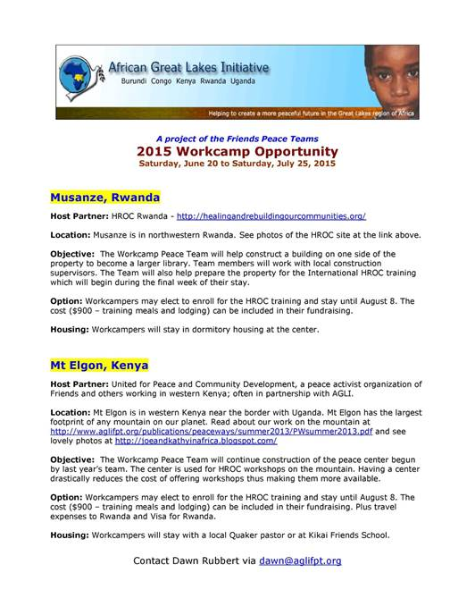
CYM Session Information - CYM clerk's letter of welcome
For full info and registration forms, please go to www.quaker.ca/ wp-content/uploads/2015/03/Insert-UPEI.pdf
Dear Friends
Welcome to Canadian Yearly Meeting 2015! This year we will be gathering at a (new for us) eastern site, the University of Prince Edward Island in Charlottetown. UPEI has very comfortable facilities, and will require us to come to one of Canada’s beauty spots in what we hope will be a most wonderful month of 2015!
Yearly Meeting in session is a unique opportunity for Friends from all across the country to come together for fellowship, worship, decision-making, learning and fun! CYM is a once-a-year time to renew old friendships, to create new ones, and to refresh our spirits. What a gift!!
Each year the Sunderland P Gardner Lecture and the Quaker or Bible Study offer us unique opportunities for spiritual growth and deepening.
Alastair McIntosh is this year’s SPG Lecturer. Alastair is a Scots Quaker with whom I had the pleasure of working when I lived in Glasgow. Alastair is being led to bring to us his wisdom about spiritual activism, grounded in work that he has done in Nova Scotia. Alastair’s title is Decolonising Land and Soul: a Quaker Testimony.
Our Quaker Studies leader this year is an old F/friend. Deborah Fisch is a frequent visitor to Canadian Yearly Meeting. This year she will engage with us on The Joy of Meeting For Worship With Attention to Business.
Other opportunities at Canadian Yearly Meeting include Special Interest Groups (SIGs), Special Action Groups (SAGs), worship sharing or study groups, and a full and enriching program for the children and youth who attend. Consider coming early to participate in the pre-CYM retreat under the care of Continuing Meeting of Ministry and Counsel. This year the topic is Nurturing Joy in Our Meetings led by Lesley Read of New Brunswick MM.
Please discern, as Meetings and as individuals, the rightness of your joining us in Charlottetown! We are enriched when we join together from across the country during this one time of the year. I know that some feel unable to attend out of concern for the carbon impact of travel. For those unable to join us, please join us in spirit, holding CYM in the Light as we gather. That, too, is an immense contribution to our spiritual community!
Elaine Bishop, Presiding Clerk

Remaining sections include (inter alia): Financial Assistance, Lodging (no camping), Meals (no food co-op), Descriptions of pre-CYM retreat, Quaker Study, SPG Lecture, Special Interest/Active Groups (how to apply to offer), Special Weekday Events, Programs for Children and Youth, how to get there, and of course info re fees and registration forms.
Vancouver Monthly Meeting and Lower Mainland Worship Groups
Vancouver Meeting House: 1090 W. 70th Ave. Sundays, 10:30 AM, childcare provided. First Sunday, singing at 9:50, First Day School, potluck lunch, Light Group (see below). Second Sunday, singing at 9:50, Business Meeting (see below); Third Sunday, "Newcomers' Group" (see below).
Fraser Valley Worship Group: meets the second and fourth First Days (Sundays) of each month at 10:30 a.m. at members’ homes. There will be tea and conversation after at 11:30. For information, please contact Meredith at 604-832-0954 or Meredith.egan@gmail.com
North Burnaby /Cranberry Commons Worship Group: 4272 Albert St., Burnaby. Fourth Sunday, Sept – June. Breakfast potluck at 9:30. Meeting for worship at 10:30 AM. Contact Ruth Walmsley and Tim Bartoo: 604-298-9220.
Coquitlam Worship Group: 940 Canyon Ct., Coquitlam, Third Sundays at 10:30 AM. Contact Earl Morris: 604-939-1348.
Bowen Island Worship Group: Fourth Sunday of each month. 10:40 for singing, 11:15 for worship. Followed by potluck and discussion. Contact Bev Rogers to confirm - and to arrange for pickup from ferry: 604-.947-2681
*Surrey, Sunshine Coast, and North Shore worship groups are not currently meeting. The Richmond/Steveston group has been laid down. Please see the Welcome page of Vancouver.quaker.ca for contact information.
Ongoing Events at the Vancouver Meeting House
Light Group: George Fox and the Early Friends Study Group aka the Light Group meets first Sundays after Meeting for Worship at 12:15, unless another program is planned for that time, in which case the Light Group will meet at 9 a.m. Please consider staying for an hour after Meeting (or coming early...) to discuss topics of interest to Friends.
First Day School: First Sunday beginning December 7th, during meeting. Led by Beth Lopez.
Potluck Lunch: First Sunday, after rise of meeting (Light Group participants take their food upstairs to the Meeting Room at 12:15).
Meeting for Worship with Attention to Business: Second Sunday each month, after rise of Meeting, except in summer, when one Business Meeting is held in late July covering July-August Business. All members and attenders are invited to attend.
Singing before Meeting for Worship: First and second Sundays at 9:50 am.
Newcomers Group: Third Sundays at 12:15. An opportunity for newcomers and attenders to ask questions and learn about Quaker faith and practice. Everyone is welcome.

The newsletter comes out in January, March, May, July, September, and November (odd-number months for odd, or at least peculiar, people). Deadline for submissions is in the middle of the month prior to publication of the newsletter (i.e., June 15th for the July issue). Please submit to Vancouverquakernewsletter@outlook.com or give to Yvette at the Meetinghouse. Send files as e-mail text or MS Word docs or docx, please. Announcements to MaxineKL@shaw.ca by around the 25th of the month.

