BETWEEN FRIENDS
Newsletter of the Vancouver Monthly Meeting of the
Religious Society of Friends (Quakers)
http://vancouver.quaker.ca/
August 2015
NOTE FROM THE EDITOR: The opinions expressed in this Newsletter are the opinions of the individual authors and may not reflect the opinions of the Newsletter Committee or of Quakers generally. (This applies to past, present, and future issues of Between Friends.)
Newsletter items are now to be forwarded to Vancouverquakernewsletter@outlook.com
KAIROS ROLLING JUSTICE BUS TOUR
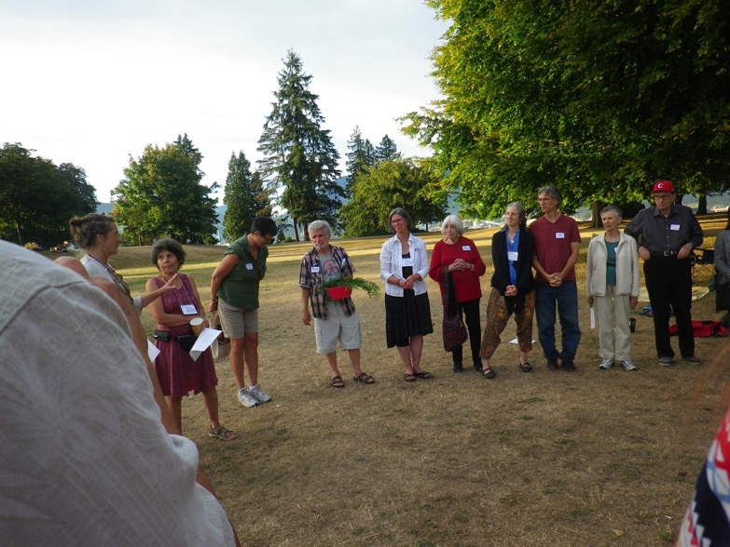

-

------------------------------------------
Table of Contents

Kairos Rolling Justice Bus Tour Page 1
Musqueam Tour Page 2
Kairos National Fracking Forum Page 2
Eritrean Conscientious Objector/ Refugees and Us Page 3
News from News from the VaMM Library Committee Page 4
Vancouver Monthly Meeting, Worship Groups, and Ongoing Events Page 4, 5
1090 West 70th Avenue, Vancouver, BC, 604-263-5015 September 2015
A farewell pot luck was held Sunday evening, August 23 at the Totem Pole Parkette in Stanley Park in support of the KAIROS Rolling Bus Tour. Its aim is to advance recommendations from the Truth and Reconciliation Report, and connect urban and rural people to critical climate change and social justice issues. Seventeen people from various faiths are travelling as a team. The BC/Yukon KAIROS-led Rolling Justice Bus left Vancouver Monday morning, August 24th, with stops in Chilliwack, Kamloops, Williams Lake, Prince George and Fort St. John. The tour returned to Vancouver on August 31. Ruth Walmsley and Maxine Kaufman-Lacusta are the Friends on board. Other participants included members of Amnesty International, the Catholic Church of Canada, the Presbyterian Church in Canada, Evangelical Lutheran Church in Canada, and the United Church of Canada. The tour will be hosted by churches along the way. It will challenge the business-as-usual status quo and articulate a new way forward based on healthy relationships, respect for the web of life and empowered communities. The tour will also engage grassroots leaders and Indigenous communities on what reconciliation might look like in this post Truth and Reconciliation (TRC) period. We can follow their daily progress on their website at: www.kairoscanada.org
Kirsten Ebsen
p.s. from Maxine: More comments and photos of the RJB tour on Facebook at "BC-Yukon Rolling Justice Bus" and on my Facebook page (Maxine Kaufman-Lacusta)

Musqueam Tour Coming up on September 20th
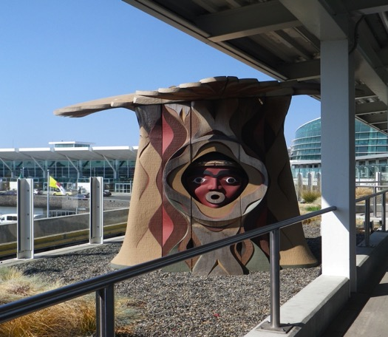
The Musqueam Tour is set for 2:00pm on Sept. 20th. Our potluck after rise of meeting should begin shortly after 12:00. Can any Friends offer lifts to those travelling by public transit? Otherwise, those of us travelling by foot should leave ½ hour before the others. It’s a wonderful walk into the community off Crown Street, with a forest on the west side of the street. We’ll be gathering at their Community Centre by 2:00pm for an official greeting. The tour is full, but am still taking names for a short waiting in case of cancellations. Directions on how to get there, by public transit and by car, will be sent via email closer to the time of.
Kirsten Ebsen orcasandfishes@gmail.com

KAIROS National Fracking Forum: A Pan-Canadian Discussion

Over the past two years KAIROS Canada has investigated the ecological and Indigenous rights issues raised by hydraulic fracturing (or fracking), the practice of injecting water, sand and chemicals deep underground at high pressure to fracture rocks and extract natural gas or oil.

On October 30 - 31, 2015 KAIROS will sponsor a public forum on fracking that will take place simultaneously in Vancouver, B.C. and Moncton, N.B. and be accessible through the internet.

The goal of the forum is to raise the profile of the social, ecological and human rights concerns of Indigenous and non-Indigenous communities across Canada and to facilitate action regionally and nationally. We will also be gathering content for an educational video.

Fracking activities have led to problems with water consumption, air and water contamination, greenhouse gas emissions and induced seismic activity.

Fracking projects have been initiated on the traditional territories of Indigenous peoples in New Brunswick, British Columbia and other jurisdictions often without their free, prior and informed consent as required by the UN

Declaration on the Rights of Indigenous Peoples and Section 35 of the Canadian Constitution.

KAIROS’ concern for Indigenous and non-Indigenous communities affected by fracking was heightened by the October 17, 2013 police raid on a peaceful blockade by members of the Elsipogtog First Nation and their allies protesting exploratory seismic testing in search of shale gas on their territory.

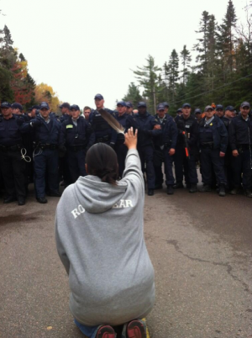

Photo credit: APTN

Similarly, Indigenous peoples in British Columbia are resisting the expansion of shale gas fracking projects and pipelines across their territories. The Unist’ot’en people are maintaining a camp to prevent surveyors for the Pacific Trails gas pipeline from entering their unceded territory.

KAIROS’ analysis of the major ecological and human rights issues raised by fracking is summarized in our discussion paper Ethical Reflections on Fracking, available at http://www.kairoscanada.org/sustainability/climate-justice/ethical-reflections-on-fracking/
To register for the forum go to https://secure.kairoscanada.org/civicrm/event/register?cid=0&reset=1&id=8

Eritrean Conscientious Objectors and Us
The Vancouver Monthly Meeting ad hoc Refugee Committee is being resuscitated. Some Friends will recall the young Palestinian family we helped sponsor through the Refugee Committee of the Unitarian Church of Vancouver a few years back. A couple of months ago, the UCV Refugee Committee approached us to help out with two young women conscientious objectors who had fled Eritrea and were waiting in a Cairo refugee camp (More details in the July issue of Between Friends). The two (names withheld for reasons of privacy) have now arrived in Vancouver and are settling in. A suitable apartment has been found and Graham, of our ad hoc committee, has already been involved in moving some furniture for them. Others of us are "on call" for English tutoring, etc. What's apparently most needed at this point is funding, since the UCV committee's resources have been stretched this summer by taking on sponsorship of three groups of refugees, one after the other. As well, the situation in Syria means that there will likely soon be more.

Please give or send donations to Graham Entwistle, our treasurer, earmarked "for the Eritrean refugees" and this money will be forwarded to the UCV committee.

Friends interested in joining the ad hoc Refugee Committee should contact me at MaxineKL@shaw.ca (subject heading: VaMM Refugee Committee) or 604-444-4690

News from the VaMM Library Committee

At its meeting on July 1, 2015, committee members formalized the structure of the committee, as requested by the new clerk. James Turner will serve as clerk and recording clerk, and Ellen Pye and Oleg Wurm as members.

Weeding calendar
As an ongoing activity, this spring Ellen Pye and James Turner continued weeding the collection. In all, about 50 cm of shelf space was reclaimed.

Overdues
Oleg Wurm has undertaken to review the book cards for items that have been on loan for extended periods, and to contact the borrowers in an attempt to have the items returned so that others may use them. Once this backlog has been processed, we will institute new procedures to improve our follow-ups.

Cataloguing pamphlets
Pamphlets are sometimes problematic because of their small size, which can cause them to get lost on the shelves. Before the catalogue was automated, call numbers of pamphlets often began with PAM to signal to users that the item is small. This designation will be removed from the call numbers so that items appear in the correct order in the catalogue.

The most important pamphlet series in our collection are the Pendle Hill Pamphlets and the Canadian Quaker Pamphlet Series. Only 4 of the former and 3 of the latter are catalogued as books, i.e. with their own call number. As a special project, we will catalogue all the pamphlets in these two series so that their titles appear in the online catalogue, but they will be kept together in special physical spaces, and not interspersed with books according to their subject. The few that have been catalogued as books will be recatalogued and put back with their pamphlet series. This work will take some time, but library users can look forward to a more predictable address for each pamphlet, as well as the possibility of learning of its existence by using the online catalogue.

Library move
In the context of the meeting house renovations, the VaMM library will need to move. Library Committee members have asked the Renovations Committee to keep them abreast of developments, so that the move can be planned. When the time comes, members and attenders will be solicited to help with the move.

Vancouver Monthly Meeting and Lower Mainland Worship Groups
Vancouver Meeting House: 1090 W. 70th Ave. Every Sunday, 10:30 AM, with childcare provided. First Sunday, potluck lunch. 604-263-5015. First Sunday, singing at 9:50 AM.
Fraser Valley Worship Group: meets the second and fourth First Days of each month at 10:30 a.m. at members’ homes. There will be tea and conversation after at 11:30. For information, please contact Meredith at 604-832-0954 or Meredith.egan@gmail.com
North Burnaby /Cranberry Commons Worship Group: 4272 Albert St., Burnaby. Fourth Sunday, Sept – June. Breakfast potluck at 9:30. Meeting for worship at 10:30 AM. Contact Ruth Walmsley and Tim Bartoo: 604-298-9220.
Coquitlam Worship Group: 940 Canyon Ct., Coquitlam, Third Sundays at 10:30 AM. Contact Earl Morris: 604-939-1348.
Bowen Island Worship Group: Fourth Sunday of each month, 10:45 am in the sanctuary at Rivendell retreat centre. Contact Bev Rogers (604 947 2681) to get picked up at the ferry.

Ongoing Events at the Vancouver Meeting House
Light Group: George Fox and the Early Friends Study Group aka the Light Group meets first Sundays after Meeting for Worship at 12:15, unless another program is planned for that time, in which case the Light Group will meet at 9 a.m. Please consider staying for an hour after Meeting (or coming early...) to discuss topics of interest to Friends.
First Day School: First Sunday of each month during meeting. Led by Beth Lopez.
Potluck Lunch: First Sunday, after rise of meeting (Light Group participants take their food upstairs to the Meeting Room at 12:15).
Meeting for Worship with Attention to Business: Second Sunday each month, after rise of Meeting, except in summer, when one Business Meeting is held in late July covering July-August Business. All members and attenders are invited to attend.
Singing before Meeting for Worship: First and second Sundays at 9:50 am.
Newcomers Group: Third Sundays at 12:15. An opportunity for newcomers and attenders to ask questions and learn about Quaker faith and practice. Everyone is welcome.

The newsletter comes out in January, March, May, July, September, and November (odd-number months for odd, or at least peculiar, people). Deadline for submissions is in the middle of the month prior to publication of the newsletter (i.e., October 15th for the November issue). Please submit to Vancouverquakernewsletter@outlook.com or give to Yvette at the Meetinghouse. Send files as e-mail text or MS Word docs or docx, please. Announcements to MaxineKL@shaw.ca by around the 25th of the month.

