Reflections on the Blanket Exercise: a Gift of Communities Coming Together for Reconciliation
A joint initiative of the Quaker Vancouver Monthly Meeting and the Vancouver Unitarian Church
By Barb Everdene
On June 9th, 2018, Vancouver Monthly Meeting gathered with the Vancouver Unitarian community on unceded Musqueam and Coast Salish territory in a beautiful intergenerational Blanket Exercise. The Blanket Exercise is a teaching tool developed by KAIROS, a network of representatives from ten churches focused on ecological justice and human rights. The exercise was created in partnership with Indigenous advisors, in response to the 1996 Report of the Royal Commission on Aboriginal Peoples, which recommended education on Canadian-Indigenous history as a key step towards Reconciliation.

Coming to terms with the colonial legacy for Indigenous peoples and ourselves
We gathered in the large sunlit atrium of the Vancouver Unitarian church, finding seats encircling many bright woven blankets spread over the floor. Our facilitator, Melaney Gleeson-Lyall of the Musqueam Nation, introduced herself and shared a ceremonial song to begin the event in a good way. Many of us had not met each other before. A low drumbeat invited us to step onto the blankets, and a warm hum of introductions filled the room. Melaney asked us to step into the roles of Indigenous peoples in Canada. Over the next 90 minutes, she led us through 500 years of colonial history—from pre-contact to treaty making, colonization and resistance. Some of us representing smallpox victims left the circle early; others were directed to leave their blankets and move to residential school. Participants each contributed to the narrative by reading scrolls with quotes from Indigenous people. As we reached the present day, the inner circle had only a handful of isolated participants on tightly folded blankets, now little islands in what had started as a living continuity of land and people.
After the exercise, Melaney invited us to participate in a Talking Circle to process the experience as a group. She began by placing herself in the history we had just walked through, sharing her experience as a survivor of the Sixties Scoop. She was firm that the exercise was not about assigning guilt and shame, but rather a call to come to terms with the colonial legacy we have all inherited. Many expressed their surprise at a history they had not learned in school—as one person shared: “I didn’t realize how systemic the violence has been.” In circle, we were moved to share experiences working with Indigenous communities and our own ancestral roots, touching on loss of language and culture, racism and persecution, sadness and shame. Some of us found our tears. With gentle attentiveness, Melaney held space for everyone to reflect on the past, the present and our hopes for a decolonized future. Gail Harwood, a retired educator, shared heartfelt words that resonated with many in the room: “I am going to spend the rest of my life taking a stand, and I will do everything in my power to ensure this system is no longer perpetuated.”

Gifts and teachings to inspire Reconciliation
To commemorate this event and important milestone on our Reconciliation journeys, the organizing committee gifted each community with a woven blanket designed by Melaney. The blanket (see image below) features a medicine wheel that reflects an important Indigenous teaching on diversity—in particular, the gifts that each of the four colours of people bring to one another and the world. The teaching suggests that the oldest people are the black-skinned – representing Indigenous peoples in Africa and Australia. Theirs is the gift of sound: singing the world into existence. Next are the red-skinned, representing the Indigenous peoples of the Americas. Theirs is the gift of stewardship of the land, waters, plants, and the animal and human world: honoring interconnectedness and maintaining the balance and harmony of all life on earth. Third are the yellow-skinned, representing the Asian peoples whose gift is deep understanding of how the human mind and body function. Last are the white-skinned, the youngest of creation. Theirs is the gift of communication: enabling all four people’s gifts to be brought together and understood by each other.
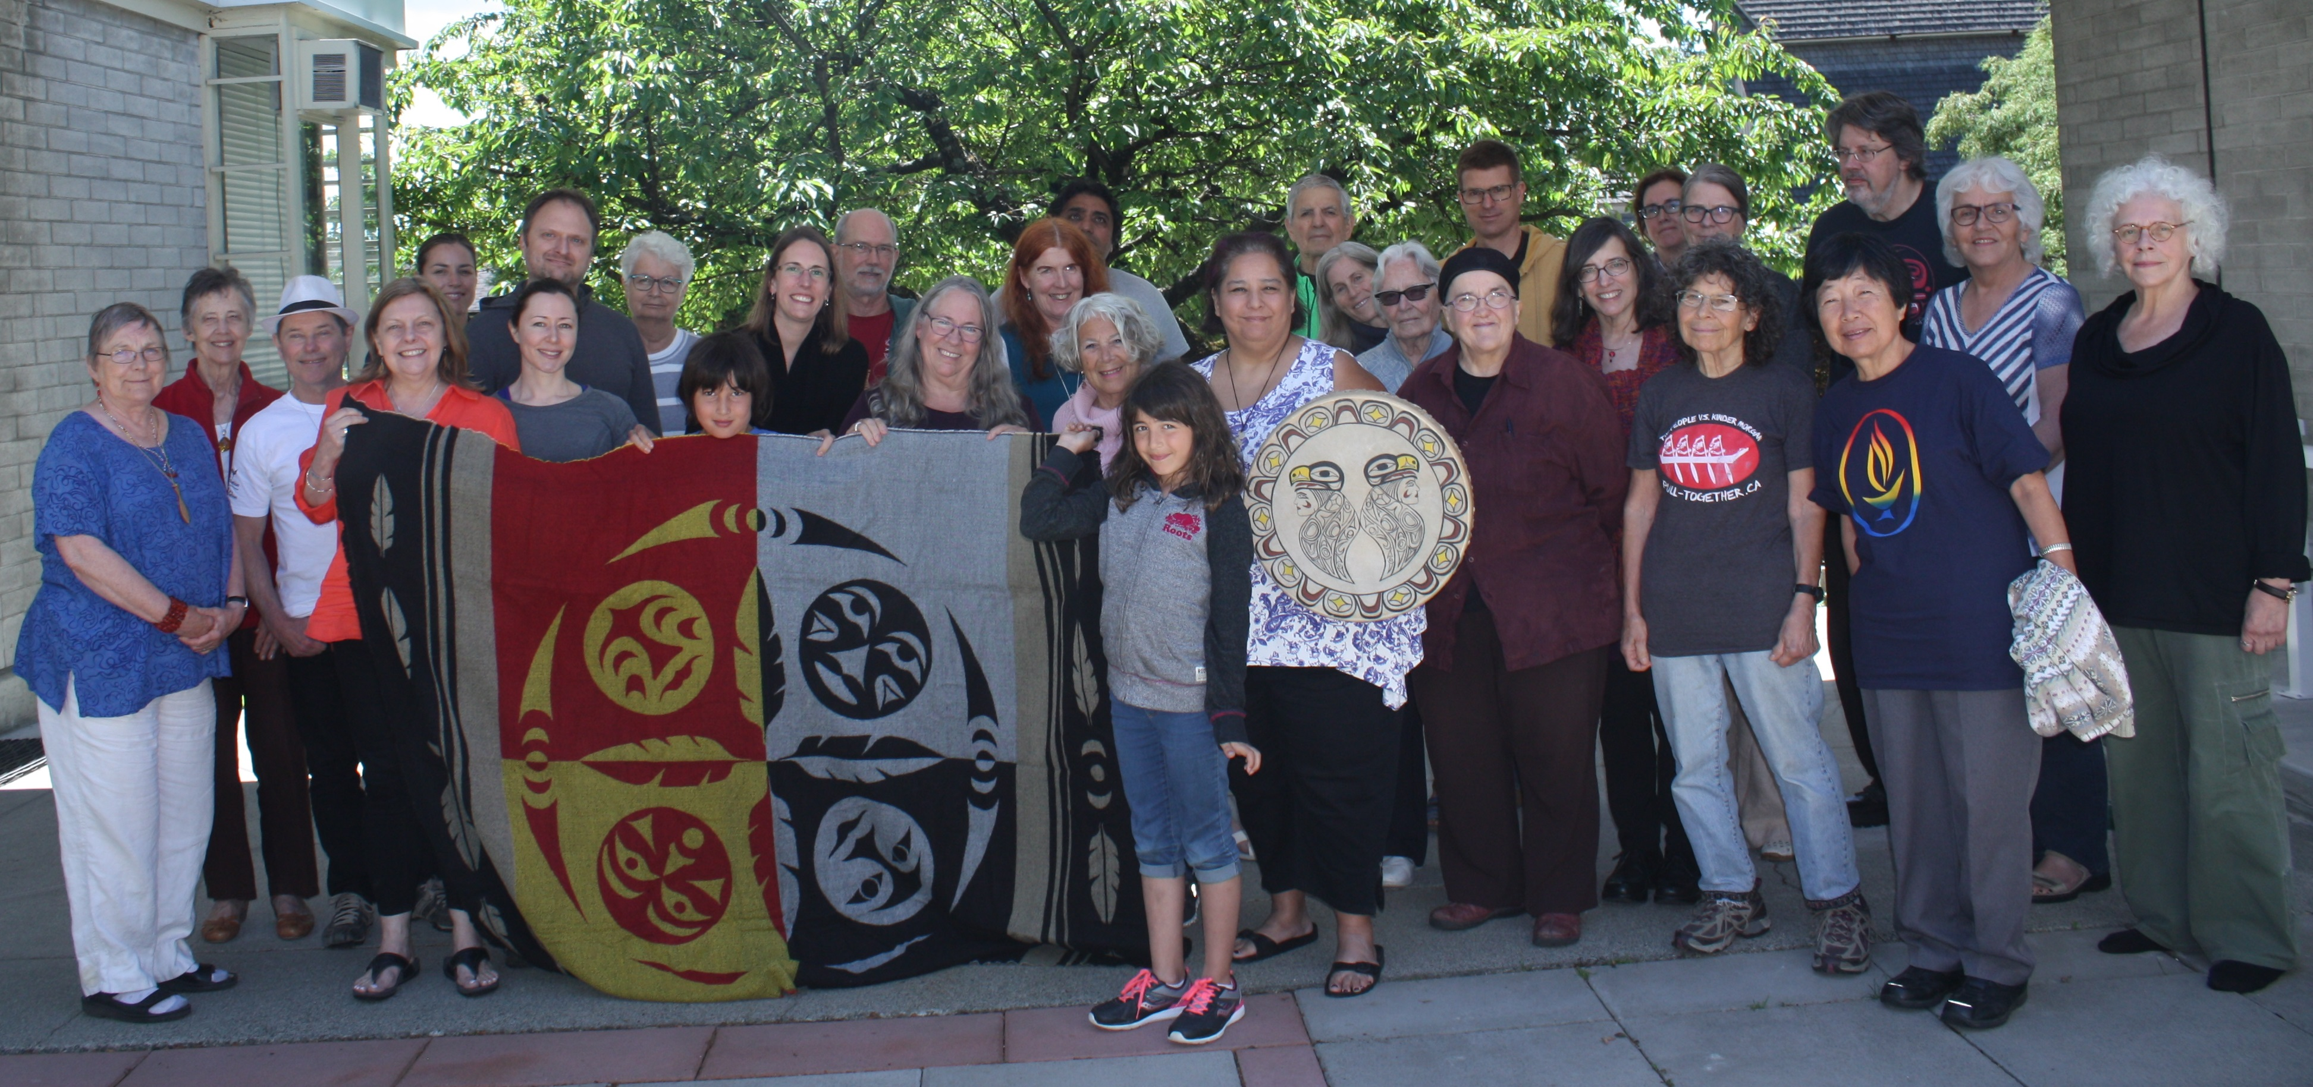
Photo Credit: Tariq Jooya
The blanket and its teaching was presented to Vancouver Monthly Meeting at Meeting for Worship for Business on June 10, 2018. Each participant was gifted with a copy of the United Nations Declaration of the Rights of Indigenous Peoples (UNDRIP). We closed the event with the joyful knowledge that UNDRIP is close to becoming a legal instrument in Canada (Bill C-262, which applies UNDRIP to Canadian law, has passed third reading and is now under review by the Senate). This achievement has come from the visionary leadership of Indigenous activists, and has been a long-term project of the Canadian Friends Service Committee. To honor Indigenous tradition and to express our appreciation for the knowledge and experienced she shared, the joint organizing committee presented Melaney Gleeson-Lyall with cedar essential oil, a pottery mug, and a book on Indigenous spirituality. Gifts of Indigenous craftsmanship were also presented to the exercise facilitators and witnesses.

Aspiration, education and action: building relationships for Reconciliation
The idea for this event began with Vancouver Monthly Meeting’s aspiration to develop a closer connection with the Musqueam First Nation. Our Meeting House in Marpole is on unceded Musqueam territory, within a close walking distance of c̓əsnaʔəm (also known as the Marpole Midden), an ancient village and burial site dating back at least 4,000 years. While many of us in the Meeting have personal connections to Indigenous friends and organizations, we wanted to explore ways to engage with the Musqueam in a more formal way, beginning with respectful acknowledgement of our presence on their unceded traditional territory.
Reconciliation Committee member and lead event organizer Rachel Yordy worked thoughtfully with Melaney Gleeson-Lyall to invite Indigenous Elders from the Musqueam Nation (and the Vancouver Aboriginal Friendship Society) to serve as witnesses at the Blanket Exercise. Although none could attend the gathering this time, we were pleased to share our journey and desire to get to know them and find ways to work together in solidarity. Through the organizing process, Rachel Yordy affirmed that the Blanket Exercise is primarily a transformative education tool for settlers. She explained, “This exercise gets to the ‘truth’ part of Truth and Reconciliation—understanding the truth is how we can begin to heal our relationships with Indigenous peoples. This is the work before the work. Before we can act in solidarity with Indigenous communities, we need to develop a shared understanding and an embodied experience of the colonial history they have endured. This healing circle, so beautifully facilitated by Melaney, will help us approach our Musqueam neighbours with mind and heart prepared.”
It has been a gift to work together on this project with the Unitarian community and learn more about their Reconciliation work, including their Truth, Healing and Reconciliation Reflection Guide. We look forward to strengthening the connection between our communities and our shared goals in Reconciliation education and action.

Acknowledgements
Our deep gratitude to Melaney Gleeson-Lyall for sharing her wisdom, courage and strength with us as the facilitator of this event. A warm thank you to the Unitarian Social Justice Committee for hosting, providing financial assistance and childcare. We also thank the Vancouver Monthly Meeting (Quaker) Reconciliation Committee for event planning and facilitation support (Kirsten Ebsen and Maxine Kaufman-Lacusta). A very special thank you goes out to Leslie Kemp and Rachel Yordy, who served as lead organizers of the event. Finally, we would like to share our gratitude to John and Nancy Denham, who have been actively engaged in Reconciliation with the Shíshálh Nation, for joining us as witnesses.

Resources
Canadian Unitarian Council – Truth, Healing and Reconciliation
Vancouver Quakers
Canadian Friends Service Committee
KAIROS and KAIROS Blanket Exercise
United Nations Declaration of the Rights of Indigenous Peoples (UNDRIP)
Report of the Royal Commission on Aboriginal Peoples

Adapted from Returning to the Teachings, Rupert Ross (2006) and Jessie Sutherland’s Worldview Skills: Transforming Conflict from the Inside Out (2005).
CFSC is the social justice arm of the Canadian Quaker community.

